PWM Output

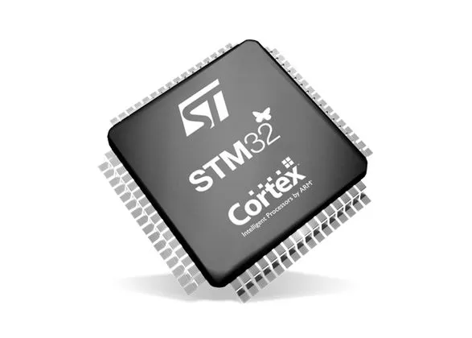

Semester 3 Embedded Systems

Lab_04_PWM_Output

Oct 8, 2022.

Student: Andre Sanao

Course: Technology

# Introduction

The purpose of this assignment is to setup a Timer to be able to use the Pulse Width Modulation (PWM) feature. With this feature, PWM signals can be produced to make more accurate values. The learning outcome of this assignment is to know how to count and measure output signal frequency and use these signals to output on external devices.

# Research

In this section is about how the timer of the STM32 was researched and implement. In the previous lecture, Interrupts were triggered by external sources such as button presses. The interrupt enters a handler where it sets and resets the flag.

A timer is a special piece of hardware that is located inside the microcontroller. Timers count up or down depending on the configuration. For example a timer that count to 10 and once it reaches 10, it will roll back to 0 and counts again. Same with the count down where it starts from 10 and rolls back from 0. The way they function can vary from the settings that is applied inside the microcontroller. For example the timers roll back from 5 instead of the maximum of 10. Additionally, it is possible to connect other hardware inside the microcontroller to the timer, like toggling a PWM pin automatically when the timer rolls over.

These are some of the common functions that is available in the timer:

* Capture compare register (CCR): toggle the pin when it reaches a certain value.
* Pulse Width Modulation (PWM): toggle a pin when the timer reaches a certain value and on roll back. Adjusting the on and off time (Duty Cycle) can effectively control the amount of current that is going inside the external hardware.
* Prescaler (PSC): all timers require some sort of clock and this clock can alternate the speed of the timer.
* Auto reload register (ARR): this register resets the period when it reaches the maximum value or whenever the period reaches the value that is set on the CCR.

# Design

Figure Timer Example

In figure 1 is an example on how the timer frequency is calculated. With the formula $Ftimer=\frac{\frac{Fclk}{PSC}}{ARR}$, the timer period can be configured. For example to configure an LED with a brightness of 50%, the LED PWM duty cycle needs to be HIGH 50% of the period. The CCR value need to be half of the maximum value of the ARR to achieve a 50% on time.

# Testing

In the Testing section, assignment was giving to configure external hardware’s such as an LED and servo motor (SG90). TIM2 which is 32 bit and a clock frequency of 72Mhz was used for the demo of the assignment. For the first part of the test it to make an LED brightness to 75%. The formula to calculate the CCR2 is $CCR=\frac{Duty Cycle}{ARR-1}=\frac{0.75}{1000-1}=750$.

The second part of the assignment is to make the led pulse between 20% and 100%. This is achieved with the CCR2 value incrementing/decrementing between 200 and 1000. Additionally, Center-aligned mode 1 was set so that the counter counts up and down alternatively.

The last part is to make a servo rotation pattern of 0 $°$ wait 1 sec, move to 90 $°$, wait 1 sec, move to -90 $°$, wait 1 sec and then move to 0 $°$. The servo data sheet was used to get the information of the PWM positions.

All 3 tests have a visual demonstration file that comes with this report.

# Conclusion

The conclusion of this lab assignment is that the timer has more functions than what was tested in this assignment. This assignment is merely understanding how to manipulate the registers to make a timer execute with different period and duty cycle. It has the same terms like the previous assignment which made it easier on how the timer frequency is calculated.

# Bibliography

STMicroelectronics NV. (2017). *RM0316 Reference manual* [Ebook]. Retrieved from <https://www.st.com/resource/en/reference_manual/dm00043574-stm32f303xb-c-d-e-stm32f303x6-8-stm32f328x8-stm32f358xc-stm32f398xe-advanced-arm-based-mcus-stmicroelectronics.pdf>

STMicroelectronics. (2018). STM32F303xB STM32F303xC [Ebook]. Retrieved from <https://www.st.com/resource/en/datasheet/stm32f303vc.pdf>